**Date: 22-11-2021**

**Experiment 9**

**Aim:** To work with input/output functions in MATLAB.

**Apparatus:** MATLAB Software

**Objective:** To learn about MATLAB’s input/output capabilities.

**Problems:**

**Q-1** The acceleration due to the Earth’s gravity at any height *h* above the surface of the Earth is given by the equation



where *G* is the gravitational constant (6.672 × 10-11 N m2 / kg2), *M* is the mass of the earth (5.98 × 1024 kg), *R* is the mean radius of the Earth (6371 km), and *h* is the height above the Earth’s surface. If *M* is measured in kg and *R* and *h* in meters, then the resulting acceleration will be in units of meters per second squared. Write a program to calculate the acceleration due to the Earth’s gravity in 500 km increments at heights from 0 km to 40,000 km above the surface of the Earth. Print out the results in a table of height versus acceleration with appropriate labels, including the units of the output values. Plot the data as well.

**Code:**

clc;

clear all;

close all;

G=6.672e-11;

M=5.98e24;

R=6.371e6;

h=0:5e5:4e7;

g=-G.*M./(R+h).^2;

fprintf('Height\tGrav. Acc.\n');

for ii=1:length(g)

fprintf('%5d\t%5d\n', h(ii), g(ii));

end

plot(g,h)

**Output:**

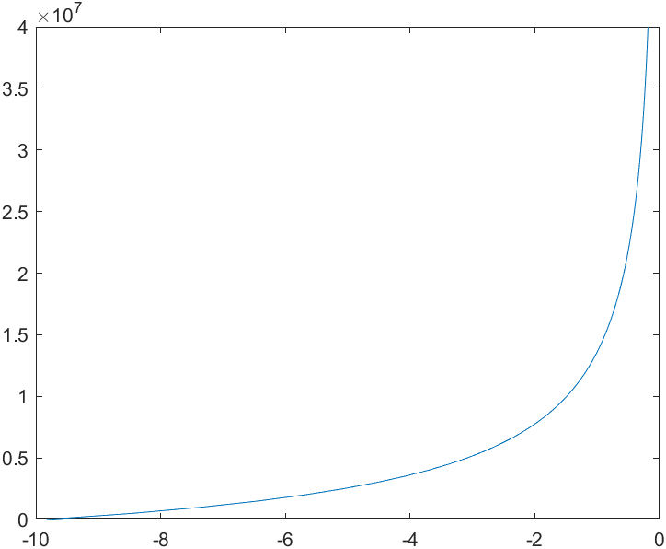

**Q-2.** Write a program that reads an arbitrary number of real values from a user specified input data file, rounds the values to the nearest integer, and writes the integers out to a user-specified output file. Make sure that the input file exists, and if not, tell the user and ask for another input file. If the output file exists, ask the user whether or not to delete it. If not, prompt for a different output file name.

**Code:**

clc;

clear all;

close all;

if ~isfile('InputFile.txt')

fprintf('File do not exist');

quit

end

fileID=fopen('InputFile.txt', 'r');

A=fscanf(fileID, '%f');

fclose(fileID);

A;

A=round(A);

if isfile('OutputFile.txt')

user=input("Do you want to overwrite the file'OutputFile.txt'?[Y/N]", 's');

if(user=='Y')

file=fopen('OutputFile.txt', 'wt');

else

name=input("Enter the name of the new file: ",'s');

file=fopen(strcat(name, '.txt'), 'wt');

end

else

file=fopen('OutputFile.txt', 'wt');

end

for ii=1:length(A)

fprintf(file,'%d\n',A(ii));

end

fclose(file);

**Output:**

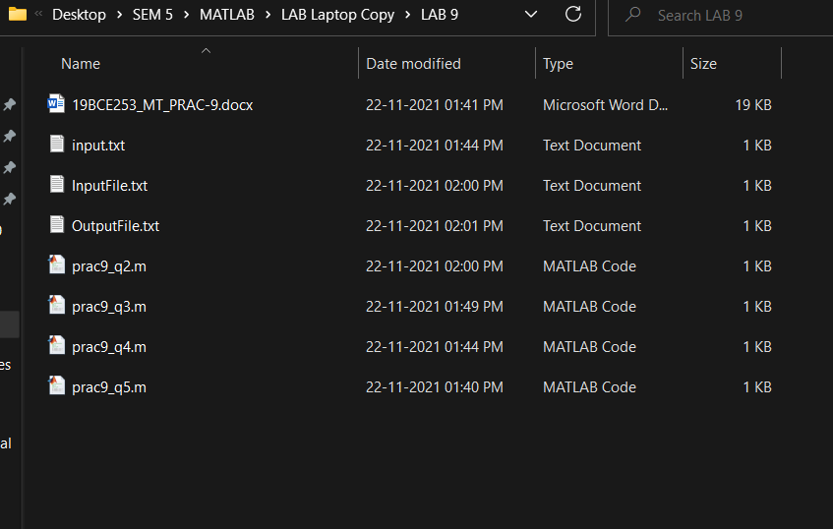

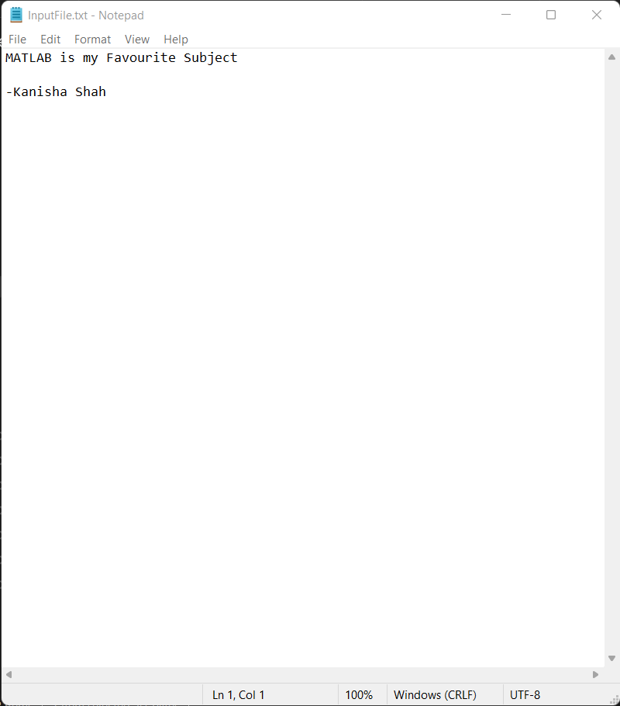

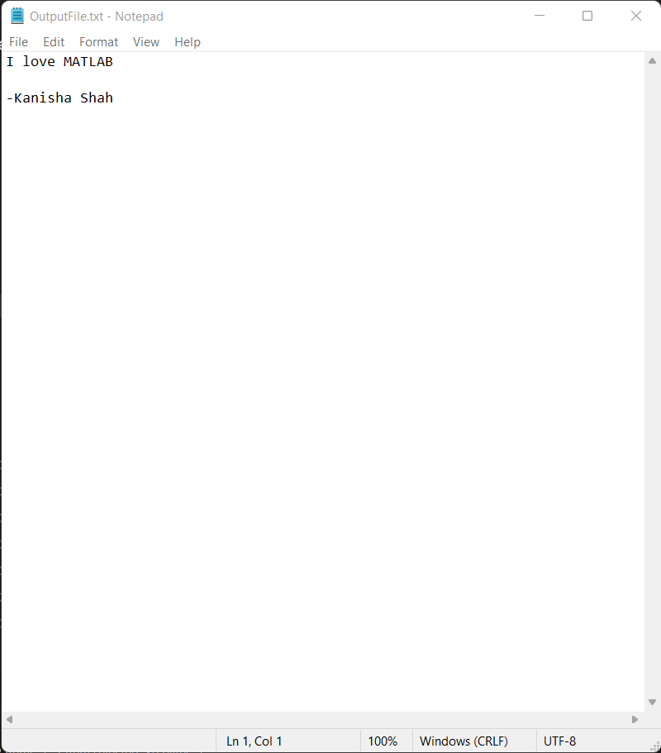

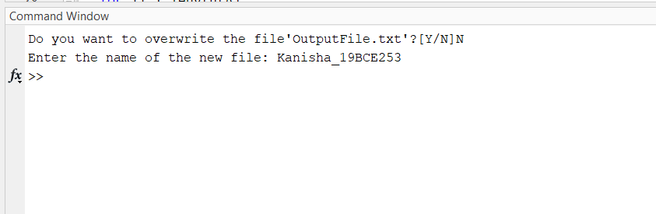

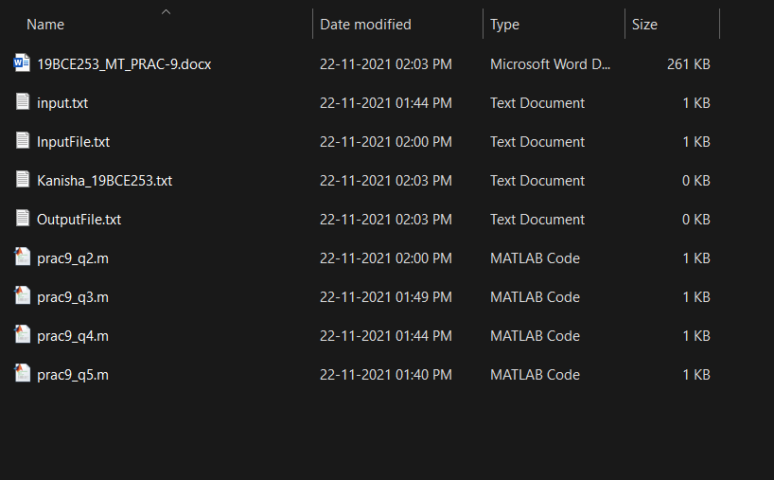

**Q-3.** Write a program to generate a table containing the sine and cosine of for between 0° and 90°, in 1° increments. The program should properly label each of the column in the table.

**Code:**

clc;

clear all;

close all;

degree=0:1:90;

degree=degree.*pi./180;

for ii=1:length(degree)

fprintf('sin(%d) = %f\t\tcos(%d) = %f\n', ii-1,sin(degree(ii)), ii-1, cos(degree(ii)));

end

figure(1)

plot(degree, sin(degree))

hold on

plot(degree, cos(degree))

legend('sin','cos')

xlabel('degree')

ylabel('function')

**Output:**

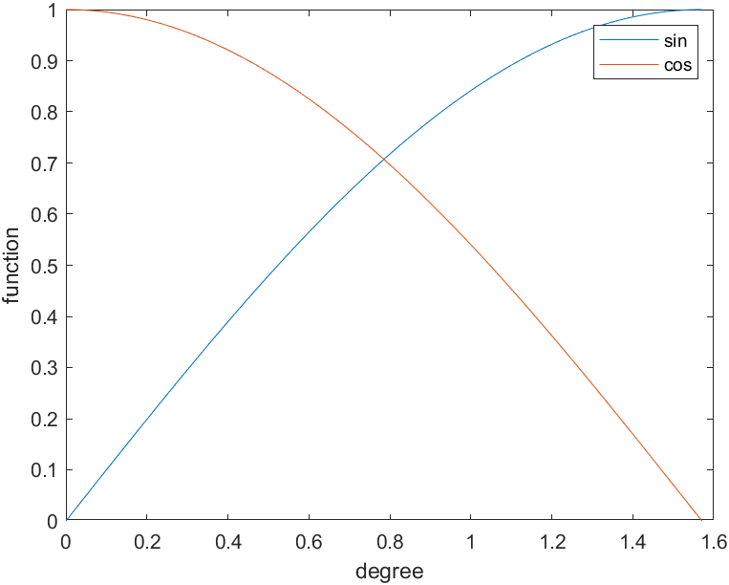

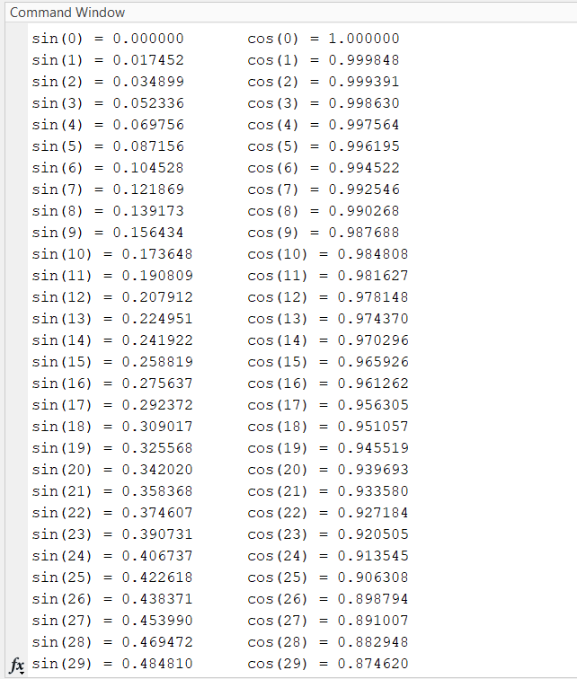

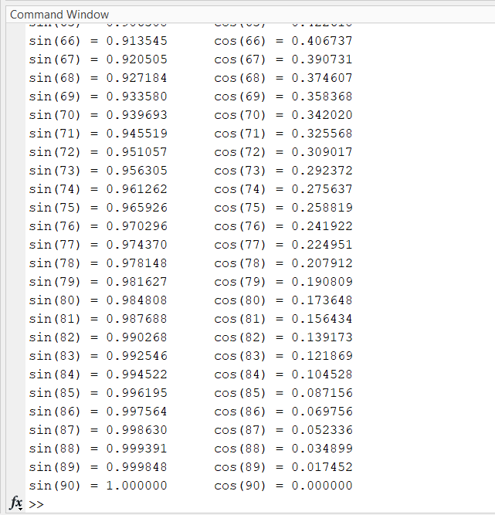

**Q-4.** Write a program to read a set of integers from an input data file, and locate the largest and smallest values within the data file. Print out the largest and smallest values, together with the lines on which they were found. Assume that you do not know the number of values in the file before the file is read.

**Code:**

clc;

clear all;

close all;

file=fopen('input.txt', 'wt');

A=randi(1000, round(rand()*10), 1)

for ii=1:length(A)

fprintf(file,'%d\n', A(ii))

end

fclose(file);

fileID=fopen('input.txt', 'r');

A=fscanf(fileID, '%d');

fclose(fileID);

**Output:**

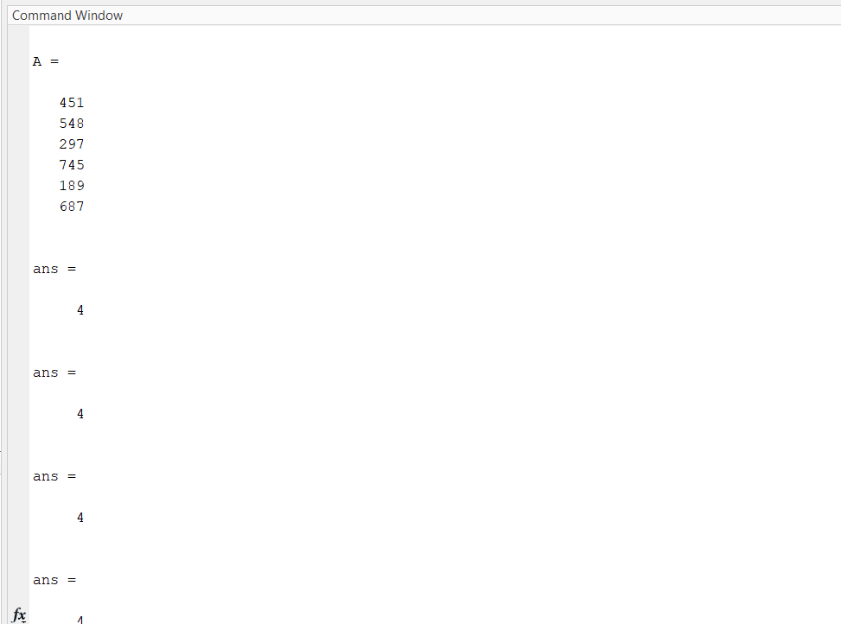

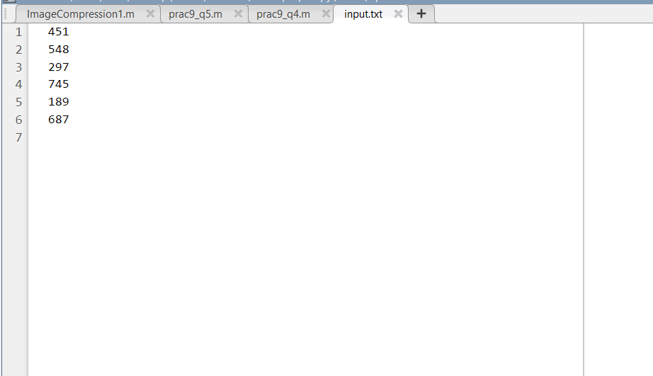

**Q-5.** Angles are often measured in degrees (º), minutes ('), and seconds ("), with 360 degrees in a circle, 60 minutes in a degree, and 60 seconds in a minute. Write a program that reads angles in radians from an input disk file and converts them into degrees, minutes, and seconds. Test your program by placing the following four angles expressed in radians into an input file and reading that file into the program: 0.0, 1.0, 3.141593, 6.0.

**Code:**

% clc;

clear all;

close all;

r=input("Enter radian: ");

degree=r*180/pi;

minute=rem(degree,1)*60;

second=rem(minute,1)*60;

fprintf("%.2d* %.2d' %.2d''\n", degree, minute, second);

**Output:**

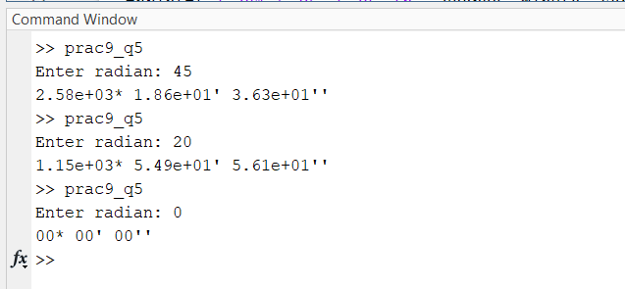

**Conclusion:**

From this experiment we learnt a lot about how to handle files and write and read input and outputs from files. We got to know the machinery that is libraries needed to work with files.